**Project 3**

**Implemented with XMLHttpRequest()**

**Link:** [**http://eecs.csuohio.edu/~evbenite/Proj3/**](http://eecs.csuohio.edu/~evbenite/Proj1/)

**Screen shots**

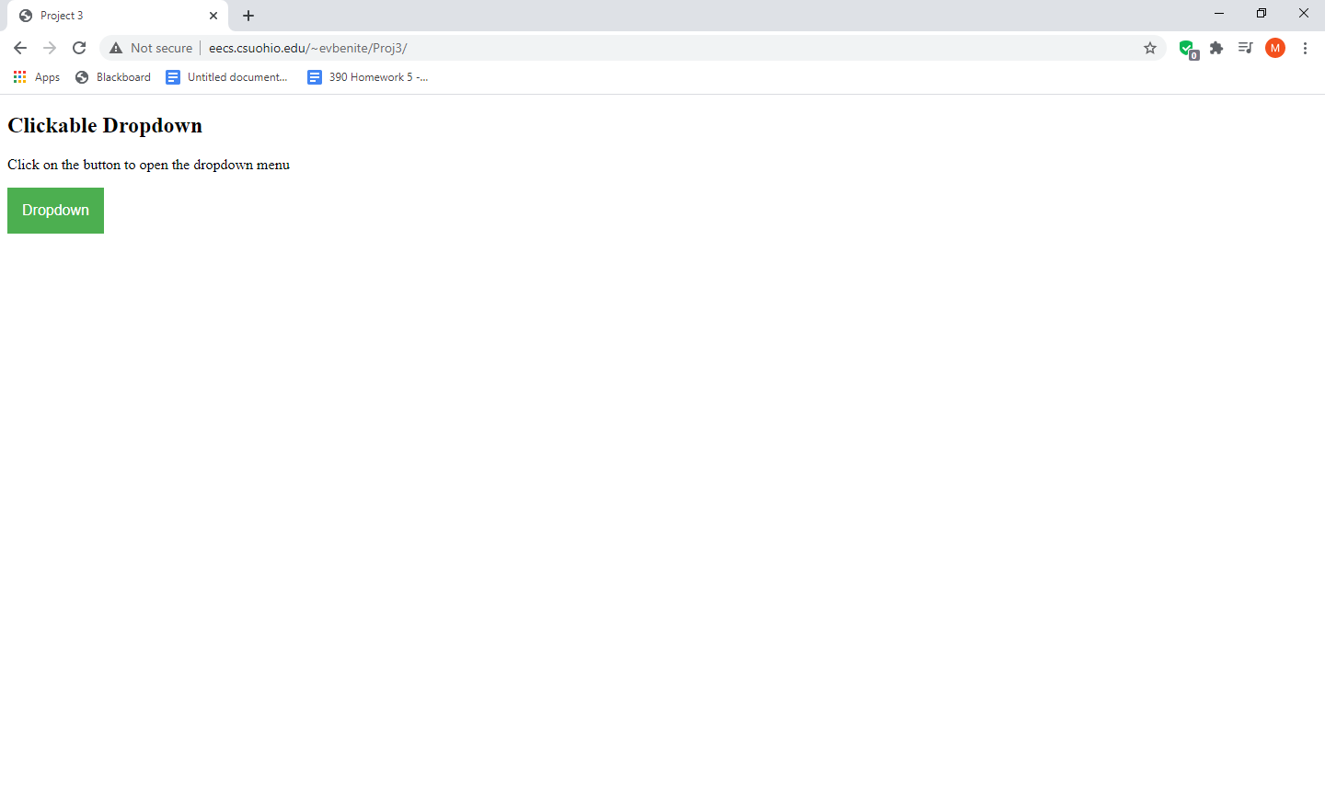

**No Options selected**

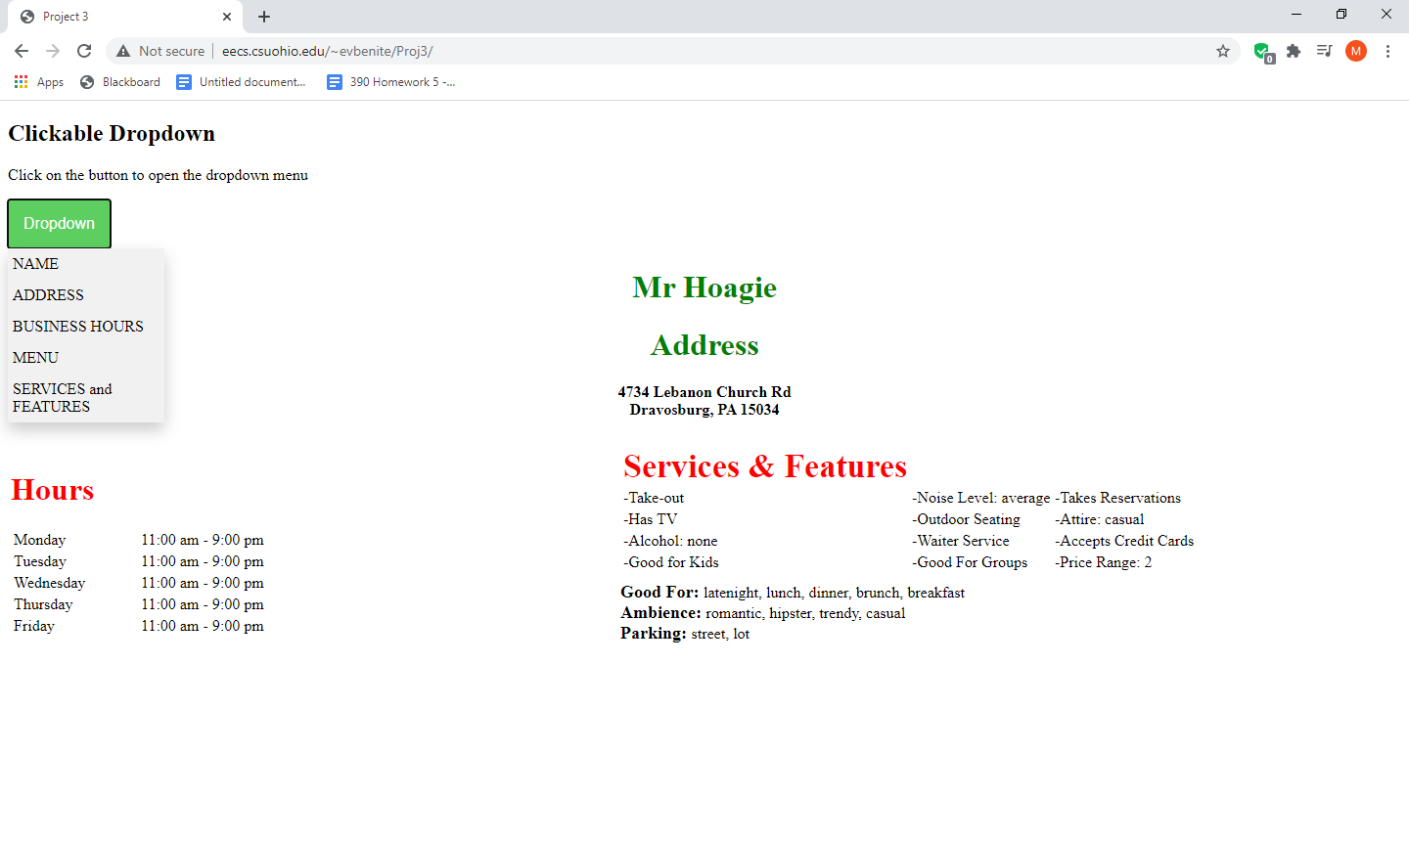

**All options selected**

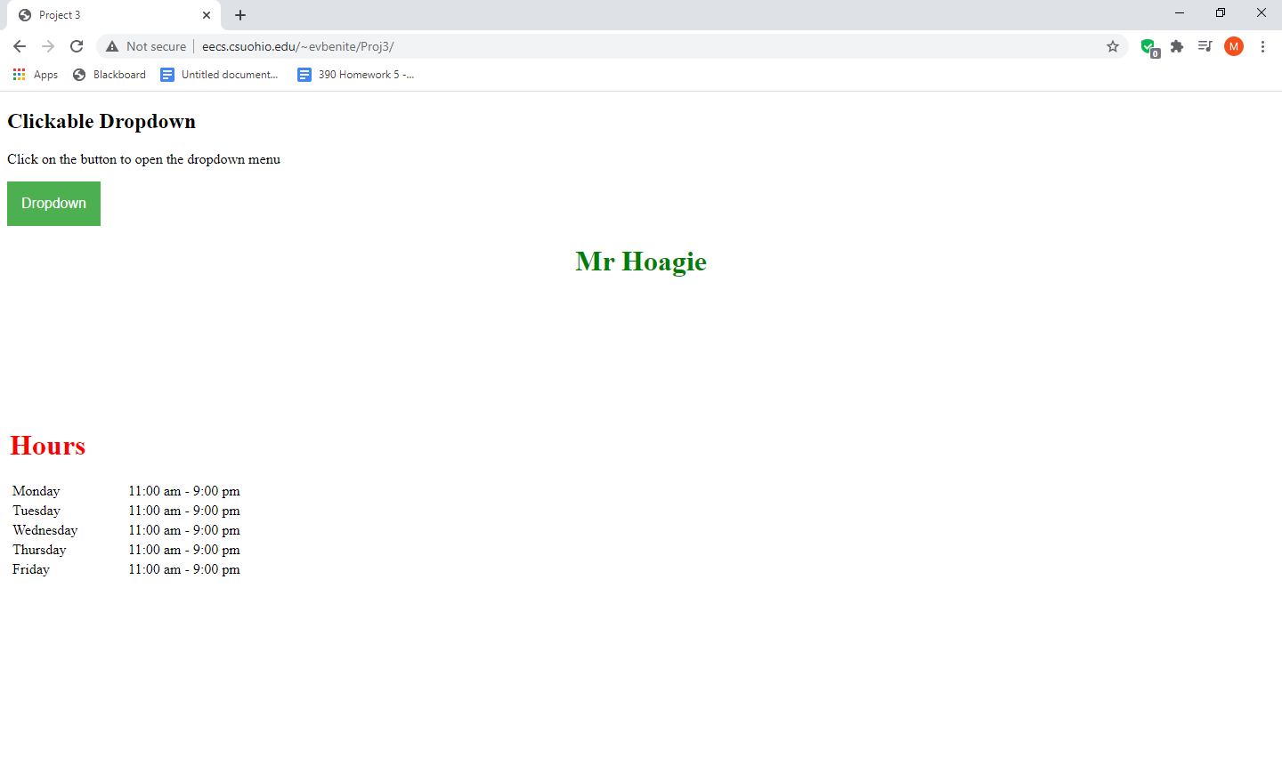

**Name and hours selected**

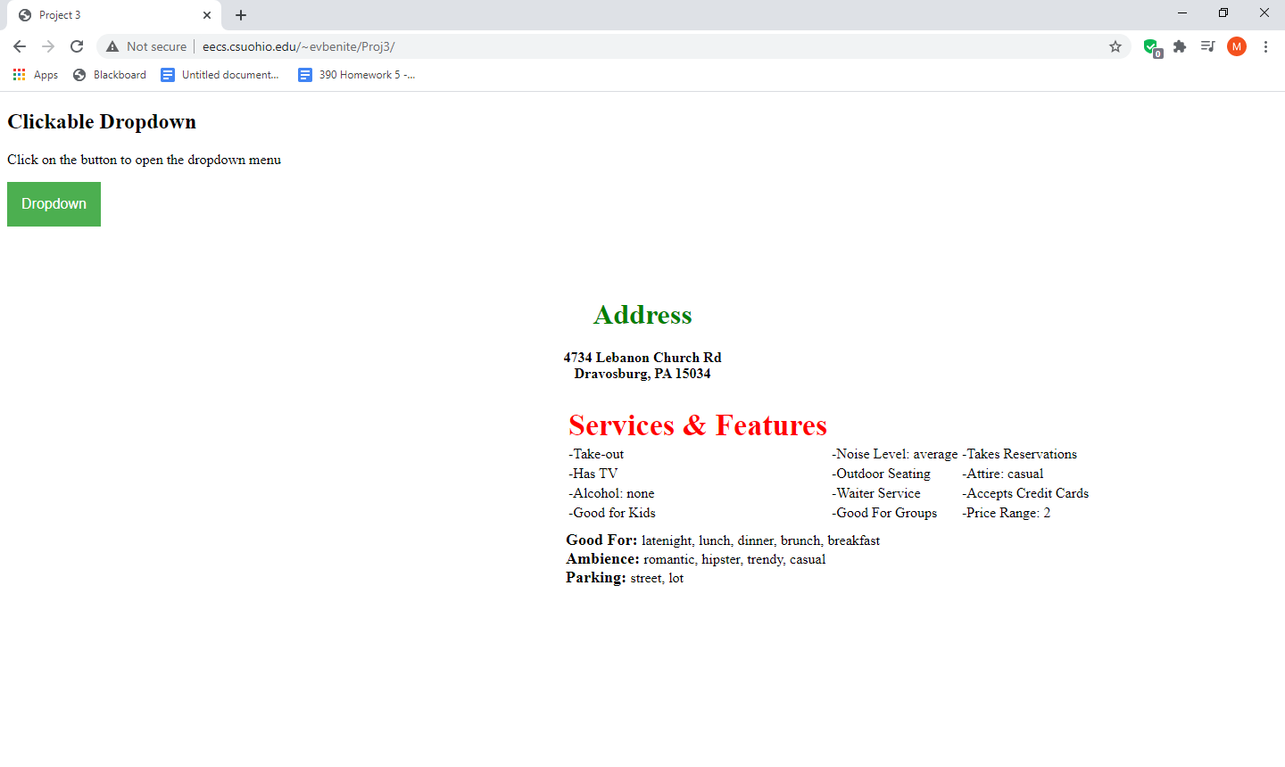

**Address, and Services and features selected**

**Code**

**Index**

<?xml version="1.0" encoding="UTF-8"?>

<!DOCTYPE html PUBLIC "-//W3C//DTD XHTML 1.1/EN"

"http://www.w3.org/TR/xhtml11/DTD/xhtml11.dtd">

<html xmlns="http://www.w3.org/1999/xhtml">

<head>

<title>Project 3</title>

<meta name="viewport" content="width=device-width, initial-scale=1"/>

<link type="text/css" href="format.css" rel="stylesheet" />

<script type="text/javascript" src="script.js"></script>

</head>

<body>

<div id="main">

<h2>Clickable Dropdown</h2>

<p>Click on the button to open the dropdown menu</p>

<div class="dropdown" onclick="menuClick()">

<button class="dropbtn">Dropdown</button>

<div id="menu" class="dropdown-content">

<a onclick="getName()">NAME</a>

<a onclick="getAddress()">ADDRESS</a>

<a onclick="getHours()">BUSINESS HOURS</a>

<a onclick="getMenu()">MENU</a>

<a onclick="getServicesAndFeatures()">SERVICES and FEATURES</a>

</div>

</div>

<div>

<div id="bName"></div>

<div id="bAddress"></div>

<div>

<table>

<tr>

<td class="left"><div id="bHours"></div></td>

<td class="right">

<table style="width: auto;">

<tr>

<td class="feature"><div id="attributes1"></div></td>

</tr>

<tr>

<td class="feature"><div id="attributes2"></div></td>

</tr>

</table>

</td>

</tr>

</table>

</div>

</div>

</div>

</body>

</html>

**Formate.css**

.dropbtn {

background-color: #4CAF50;

color: white;

padding: 16px;

font-size: 16px;

border: none;

cursor: pointer;

}

.dropbtn:hover, .dropbtn:focus {

background-color: #5CcF60;

}

.dropdown {

position: relative;

display: inline-block;

}

.dropdown-content {

display: none;

position: absolute;

background-color: #f9f9f9;

min-width: 160px;

overflow: auto;

box-shadow: 0px 8px 16px 0px rgba(0,0,0,0.2);

}

.dropdown-content a {

color: black;

padding: 7px 5px;

background-color: #f1f1f1;

display: block;

cursor: pointer;

}

.dropdown-content a:hover {

background-color: #dddddd;

}

table {

width: 100%;

}

#bName, #bAddress {

text-align: center;

}

.left {

width: 25%;

}

.right {

width: 75%;

float:right;

}

.feature {

width: 100%;

}

#attributes1, #attributes2{

padding-right: 30px;

}

.hide {

visibility: hidden;

}

.show {display:block;}

**Script.js**

var Business_Data;

var http = new XMLHttpRequest();

http.onreadystatechange = function() {

if(this.readyState == 4 && this.status == 200) {

console.log("In the ready");

Business_Data = JSON.parse(this.responseText);

init();

}

};

http.open("GET","YelpOneBusinessJsonData.txt", true);

http.send();

function init() {

// get name

var node = document.getElementById("bName");

node.innerHTML = "<h1 style='color: green;'>" + Business_Data.name + "</h1>";

node.classList.add("hide");

//get address

node = document.getElementById("bAddress");

var text = Business_Data.full_address.replace("\n", "<br />")

node.innerHTML = "<h1 style='color: green;'>Address</h1>" +

"<h4>" + text + "</h4>";

node.classList.add("hide");

//get Hours

node = document.getElementById("bHours");

var hours = "";

var x;

hours = "<table><tr>"

//this is necessary because the days are not in order

if(x = "Sunday" in Business_Data.hours) {

hours += "<td>" + x + "</td><td>" + get12HourTime(Business_Data.hours[x].open) + " - " + get12HourTime(Business_Data.hours[x].close) + "</td></tr>";

}

if((x = "Monday") in Business_Data.hours) {

hours += "<td>" + x + "</td><td>" + get12HourTime(Business_Data.hours[x].open) + " - " + get12HourTime(Business_Data.hours[x].close) + "</td></tr>";

}

if((x = "Tuesday") in Business_Data.hours) {

hours += "<td>" + x + "</td><td>" + get12HourTime(Business_Data.hours[x].open) + " - " + get12HourTime(Business_Data.hours[x].close) + "</td></tr>";

}

if((x = "Wednesday") in Business_Data.hours) {

hours += "<td>" + x + "</td><td>" + get12HourTime(Business_Data.hours[x].open) + " - " + get12HourTime(Business_Data.hours[x].close) + "</td></tr>";

}

if((x = "Thursday") in Business_Data.hours) {

hours += "<td>" + x + "</td><td>" + get12HourTime(Business_Data.hours[x].open) + " - " + get12HourTime(Business_Data.hours[x].close) + "</td></tr>";

}

if((x = "Friday") in Business_Data.hours) {

hours += "<td>" + x + "</td><td>" + get12HourTime(Business_Data.hours[x].open) + " - " + get12HourTime(Business_Data.hours[x].close) + "</td></tr>";

}

if((x == "Saturday") in Business_Data.hours) {

hours += "<td>" + x + "</td><td>" + get12HourTime(Business_Data.hours[x].open) + " - " + get12HourTime(Business_Data.hours[x].close) + "</td></tr>";

}

node.innerHTML = "<h1 style='color: red;'>Hours</h1>" + hours + "</table>";

node.classList.add("hide");

//get features

var node1 = document.getElementById("attributes1");

var node2 = document.getElementById("attributes2");

var listFeatures1 = "<table><tr><td style='color: red; font-size: 34px; font-weight: bold;'>Services & Features</td><td></td><td></td></tr>";

var listFeatures2 = "";

var count1 = 0;

for(feature in Business_Data.attributes) {

if(Business_Data.attributes[feature]) {

if(Business_Data.attributes[feature] == true){

if(count1 == 0)

listFeatures1 += "<tr>"

listFeatures1 += "<td>-" + feature + "</td>";

count1++;

if(count1 == 3){

listFeatures1 += "</tr>"

count1 = 0;

}

}

else {

if(Business_Data.attributes[feature] instanceof Object) {

//print header

for(subFeature in Business_Data.attributes[feature]) {

if(Business_Data.attributes[feature][subFeature]) {

listFeatures2 += "<b style='font-size: 18px;'>" + feature + ": </b>";

break;

}

}

for(subFeature in Business_Data.attributes[feature]) {

if(Business_Data.attributes[feature][subFeature]) {

listFeatures2 += subFeature + ", ";

}

}

//remove trailing comma

if(listFeatures2.length > 0 && listFeatures2.substring(listFeatures2.length-2,listFeatures2.length-1) == ",")

listFeatures2 = listFeatures2.slice(0,-2);

listFeatures2 += "<br />";

}

else {

if(count1 == 0)

listFeatures1 += "<tr>"

listFeatures1 += "<td>-" + feature + ": " + Business_Data.attributes[feature] + "</td>";

count1++;

if(count1 == 3){

listFeatures1 += "</tr>"

count1 = 0;

}

}

}

}

}

while(count1 != 3) {

listFeatures1 += "<td></td>"

count1++;

if(count1 == 4){

listFeatures1 += "</tr>"

count1 = 0;

}

}

listFeatures1 +="</table>";

node1.innerHTML = listFeatures1;

node2.innerHTML = listFeatures2;

node1.classList.add("hide");

node2.classList.add("hide");

}

function menuClick() {

var menu = document.getElementById("menu");

if(!menu.classList.contains("show")){

menu.classList.add("show");

}

else {

menu.classList.remove("show");

}

}

function getName() {

if(document.getElementById("bName").classList.contains("hide")){

document.getElementById("bName").classList.remove("hide");

}

else {

document.getElementById("bName").classList.add("hide");

}

console.log("in the getName");

}

function getAddress() {

if(document.getElementById("bAddress").classList.contains("hide")){

document.getElementById("bAddress").classList.remove("hide");

}

else {

document.getElementById("bAddress").classList.add("hide");

}

console.log("in the getAddress");

}

function getHours() {

if(document.getElementById("bHours").classList.contains("hide")){

document.getElementById("bHours").classList.remove("hide");

}

else {

document.getElementById("bHours").classList.add("hide");

}

console.log("in the getHours");

}

function getMenu() {

console.log("in the getMenu");

}

function getServicesAndFeatures () {

if(document.getElementById("attributes1").classList.contains("hide")){

document.getElementById("attributes1").classList.remove("hide");

document.getElementById("attributes2").classList.remove("hide");

}

else {

document.getElementById("attributes1").classList.add("hide");

document.getElementById("attributes2").classList.add("hide");

}

console.log("in the getServices");

}

function get12HourTime(time) {

if(time.length == 5 && parseInt(time.substring(0,2)) <= 12) {

return time + " am";

}

else {

return "" + (parseInt(time.substring(0,2))-12) + time.substring(2) + " pm";

}

}